PLMS User Roles
There are four types of User Roles in the Prostheses List Management System (PLMS). Your User Role(s) determines what you can see and do in the PLMS.
The User Roles are:
- User Administrator
- Reader
- Author
- Approver

The User Administrator for your organisation must assign you a User Role(s) after you register for the PLMS. You will not be able to view or edit applications unless you are assigned a User Role.
Note: A user can have more than one User Role assigned to their profile, e.g. a user can be both a User Administrator and a Reader.
Overview of User Roles
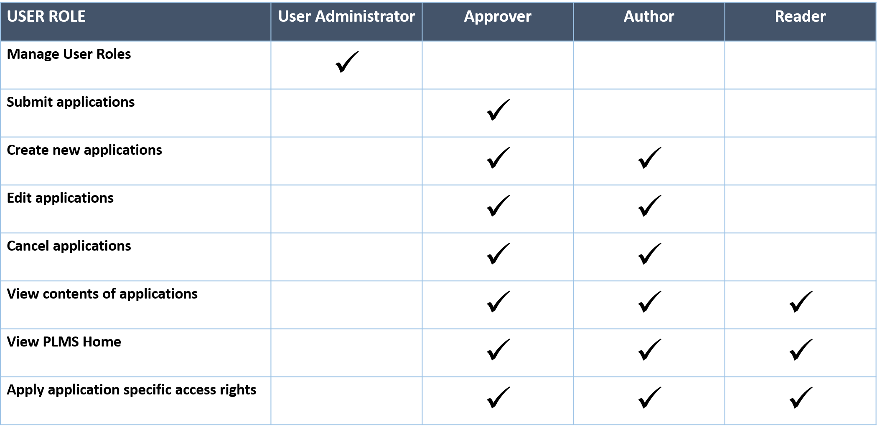

User Administrator
The Department of Health grants the User Administrator role to the first registered user in an organisation.
The User Administrator has the authority to:
- Grant User Roles (Reader, Author and Approver) to any future users in the same organisation
- Manage and revoke User Roles as required

If your organisation would like to change the User Administrator role to another person or assign the role to additional users, contact the Department of Health at prostheses@health.gov.au
Note: Health recommends having more than one User Administrator to ensure uninterrupted access to the PLMS during sick or leave days.

Reader
A Reader has the authority to:
- View contents of applications
- View the PLMS Home
- Apply access rights for an application (if listed as the ‘Primary Contact’ or ‘Secondary Contact’ on the application)

Author
An Author has the authority to:
- Create new applications
- Edit applications
- Cancel applications
- View contents of applications
- View the PLMS Home
- Apply access rights for an application (if listed as the ‘Primary Contact’ or ‘Secondary Contact’ on the application)

Approver
An Approver has the authority to:
- Submit applications
- Create new applications
- Edit applications
- Cancel applications
- View contents of applications
- View the PLMS Home
- Apply access rights for an application (if listed as the ‘Primary Contact’ or ‘Secondary Contact’ on the application)

Apply Application Specific Access Rights
Application specific access rights allow you to manage who in your organisation can view an application. This means only the users you authorise will be able to see the application listed on the PLMS Home.
You can manage access rights if you are the ‘Primary Contact’ or ‘Secondary Contact’ for the application, and you can access this function in the Application Summary section of your application.
For more information on how to apply access rights, view the PLMS User Guide – Getting Started.

Contact Information
If you have any questions about using the PLMS, contact the Department of Health at prostheses@health.gov.au

