Account Setup and Login
To gain access to the Prostheses List Management System (PLMS) you must:
- Get a myGovID
- Register for the PLMS
- Get assigned a User Role(s)

Get a myGovID
To access the PLMS, you will first need to register for a myGovID (previously AUSkey). myGovID is a secure login that allows you to access online government services on behalf of a business. Please note, myGovID is different to myGov. If you are acting on behalf of a business, you will need to set up RAM.
To get a myGovID:
STEP 1 – Download the myGovID app on a smart device
Note: must have iOS 10 or later on Apple Devices or Android 7.0 (Nougat) or later
STEP 2 – Enter your details: Open the myGovID app and follow the prompts. You will need to enter your full name, date of birth and email address.
STEP 3 – Add your identity documents. A standard identity strength allows you to access all participating government online services, if you have added two Australian identity documents such as your: driver’s license, passport, birth certificate or medicare card.
Note: If you have issues with myGovID, please contact 1300 287 539 or visit the myGovID Need Help page. If the myGovID login is working but the PLMS login is not, please contact Health for support at Prostheses@health.gov.au

Register for the PLMS
Follow the screen by screen guide to Register for the PLMS.
Prostheses List Management System Homepage | STEP 1 – Go to http://prostheses.health.gov.au  STEP 2 – For first time users, click Register on the right hand side of the screen.  STEP 3 – For regular users click Login.

myGovID Login  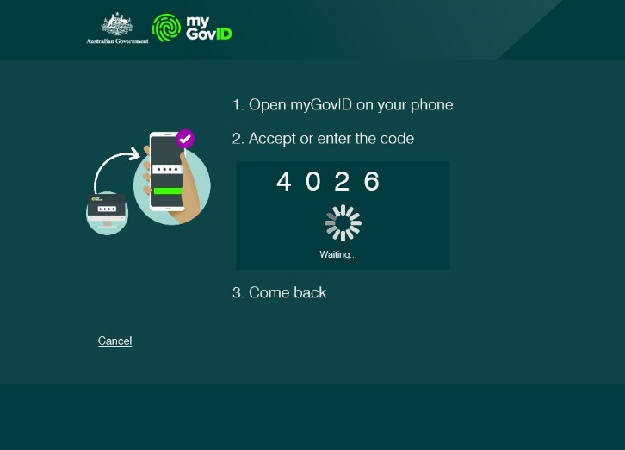  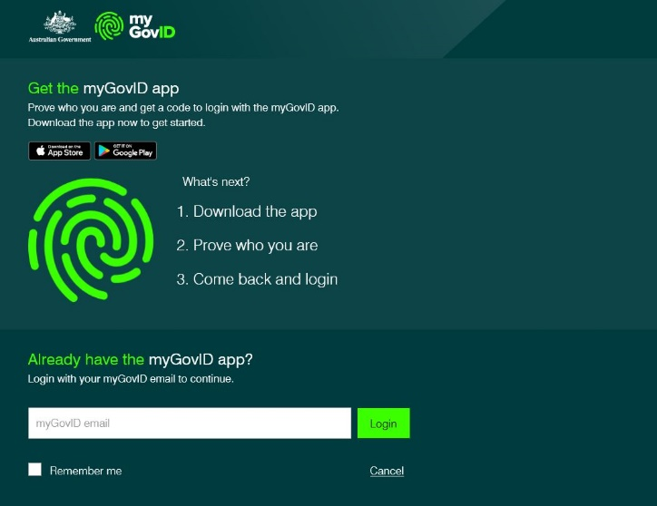  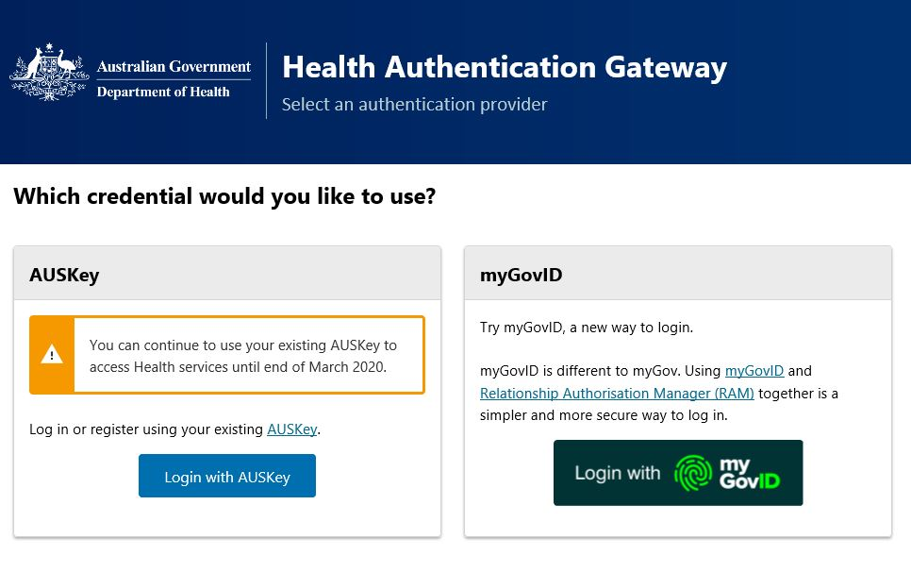 | STEP 1 – Select myGovID login.  STEP 2 – On the next screen, login using your myGovID email. If you haven’t logged in before, follow the prompts on the screen to get the myGovID app. Note: If you are acting on behalf of an organisation, you must make sure your RAM has already been set up before proceeding to the next step.  STEP 3 – Click login to go to the next page.  STEP 4 – Open the myGovID app on your phone and enter the four-digit code displayed on screen.  STEP 5 – The screen should refresh and take you back to PLMS.
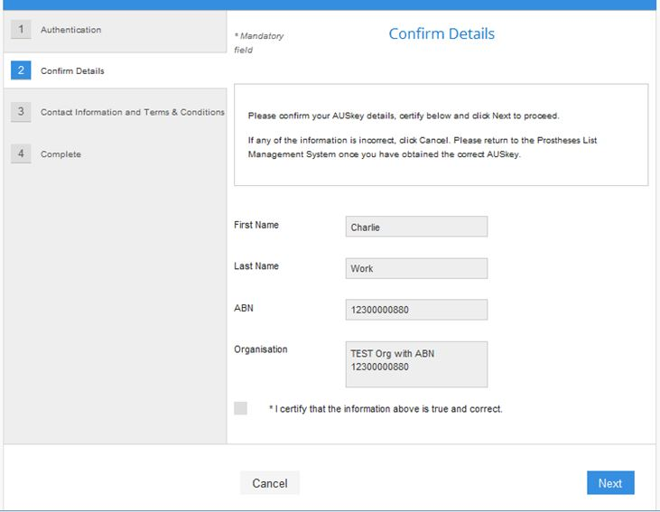  Confirm details | STEP 1 – Check your myGovID details are correct.  STEP 2 – Tick the box under your details to certify that the information above is true and correct.  STEP 3 – Click Next to save information and go to the next page.
Contact information & Terms and Conditions  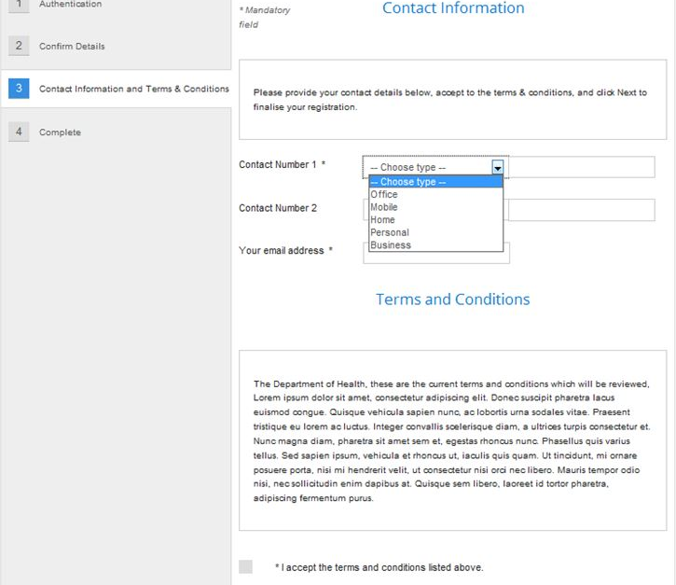 | STEP 1 – Select a Contact Number type from the drop down menu, and enter your number into the space provided.  You can also add a second contact number.  STEP 2 – Enter your email address.  STEP 3 – Read the Terms and Conditions and tick the box underneath if you accept.  STEP 4 – Click Next to complete your registration.

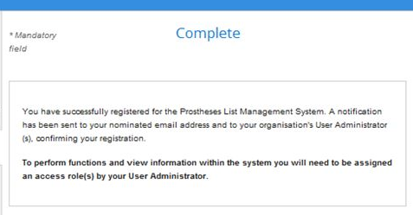  Complete | If you are presented with this screen, then you have successfully registered for the Prostheses List Management System.  STEP 1 – Click Finish to go to the PLMS Home.  Before you can view or edit applications, the User Administrator for your organisation must assign you a User Role(s).

Get assigned a User Role(s)
After getting a myGovID and registering for the PLMS:
STEP 1 – Contact the User Administrator for your organisation. The User Administrator will then assign you a role in the PLMS. If you do not know who the User Administrator for your organisation is, contact the Department of Health at prostheses@health.gov.au
Note: You will not be able to view or edit applications unless you are assigned a User Role.

For a full description of each role and its permissions, view the Quick Reference Guide: PLMS User Roles.

Contact information
If you have any questions about using the Prostheses List Management System, contact the Department of Health at prostheses@health.gov.au
If you have any questions regarding myGovID, contact 1300 287 539 or visit the myGovID Need Help page.

