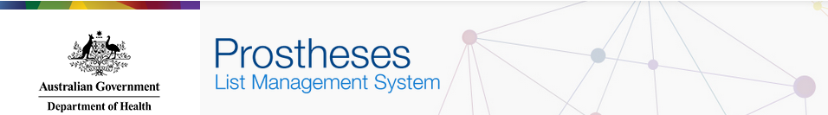

Prostheses List Management System (PLMS)
User Guide – Getting Started

Contents
Introduction 2
About 2
About this Guide 2
PLMS User Guides 3
1. Register 4
1.1 PLMS Log in 5
1.2 AUSkey Login 6
1.3 myGovID Login 7
1.4 Confirm Details 8
STEP 2 – Tick the box under your details to certify that the information above is true and correct. 8
1.5 Contact Information & Terms and Conditions 9
STEP 2 – Enter your email address. 9
1.6 Complete 10
Before you can view or edit applications, the User Administrator for your organisation must assign you a User Role(s). 10
1.7 PLMS Home 11
2. Search 12
2.1 PLMS Home 13
2.2 Search Applications 14
3. Manage User Roles 15
3. Manage User Roles 16
3.1 PLMS Home 17
3.2 List of Users 18
3.3 Prostheses Manage User Details Page 19

Introduction

About
The Department of Health developed the Prostheses List Management System (PLMS) to streamline the application process for listing a prosthesis device on the Prostheses List. The system allows sponsors and suppliers to create, edit and monitor applications for prostheses listings.

About this Guide
The purpose of this user guide is to assist sponsors and suppliers in using the Prostheses List Management System (PLMS). Pictures of the screens from the online system are used throughout this guide in order to help navigate between the portal and the guide. These screenshots are to provide a visual representation of the look and feel and are not intended to be read in full.
The PLMS User Guide – Prosthesis Device Application will provide guidance on:
- Registering for the PLMS
- Searching applications
- Managing User Roles

If you have any questions about using the Prostheses List Management System, contact the Department of Health at prostheses@health.gov.au

PLMS User Guides
There are three user guides available for the PLMS:
- PLMS User Guide – Getting Started
- PLMS User Guide – Prosthesis Device Application
- PLMS User Guide – Human Tissue Application (in development)

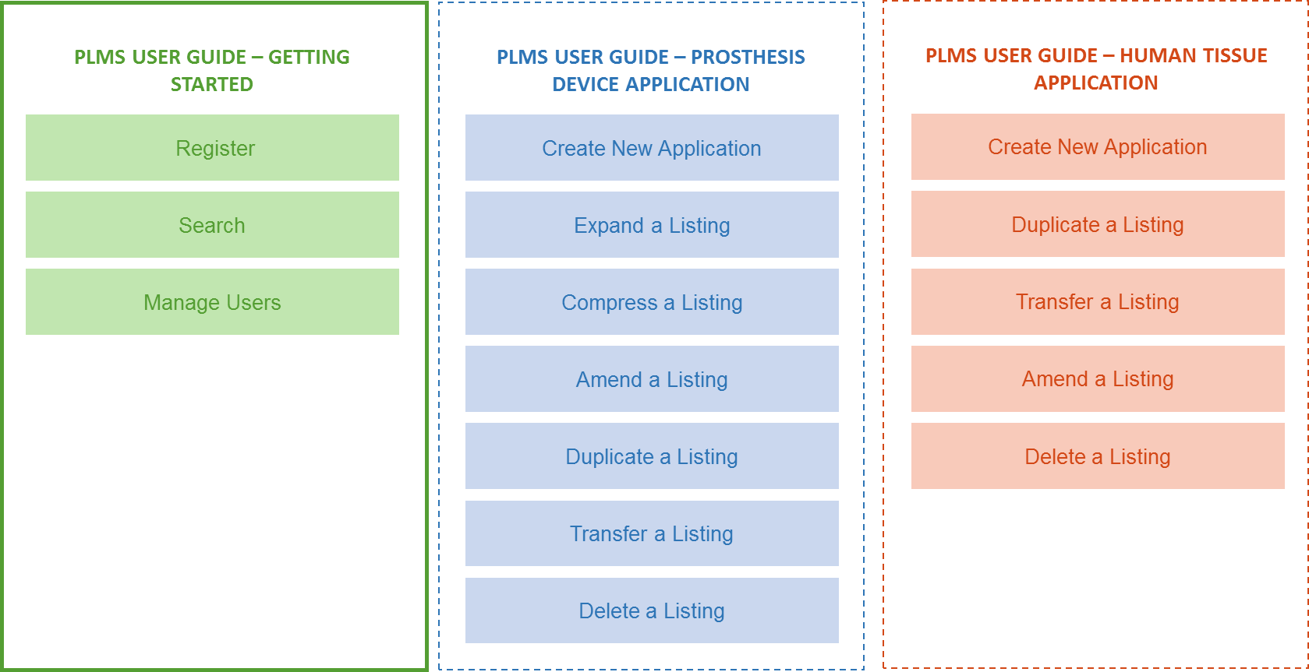

1. Register
Before you register for the PLMS, you must have:
- A valid AUSkey* or myGovID
- AUSkey software installed on your device
*AUSkey is being decommissioned at the end of March 2020. You will need a myGovID to register for PLMS from April 2020 onwards.

For information on getting an AUSkey or myGovID, visit the Australian Business Register website.

The steps to Register for the PLMS are:
Register
  - PLMS Log in
  - AUSkey Login
  - MyGovID Login
  - Confirm Details
  - Contact Information & Terms and Conditions
  - Complete
  - PLMS Home

1.1 PLMS Log in
You can access the system from the PLMS Homepage.

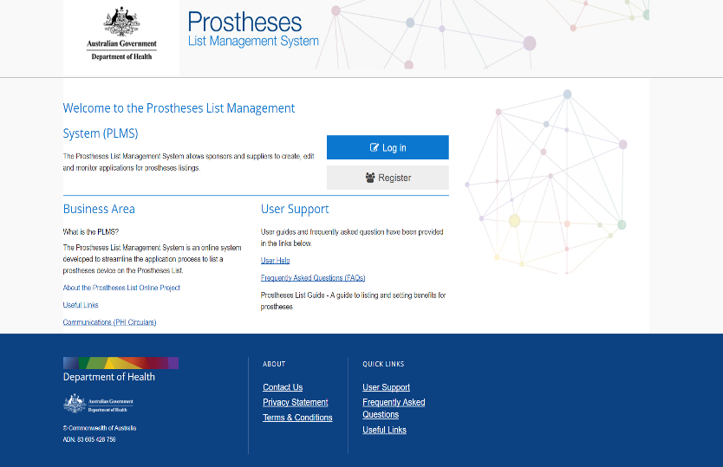
STEP 1 – Go to http://prostheses.health.gov.au

STEP 2 – For first time users, click Register on the right hand side of the screen.

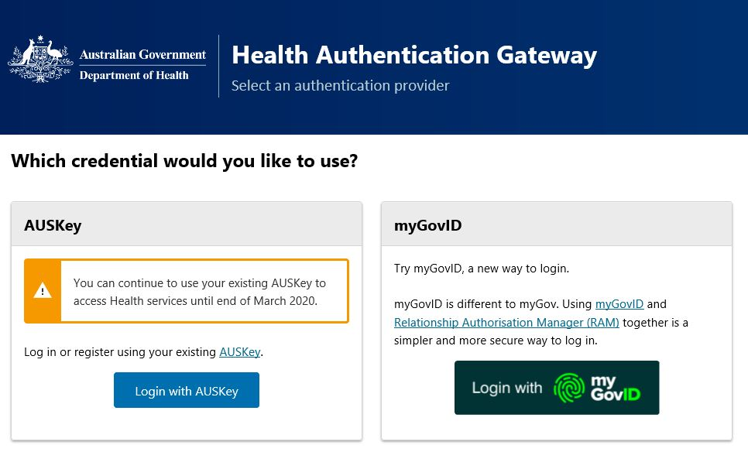

STEP 3 – A dual login screen will appear.

1.2 AUSkey Login
If you are not using myGovID, the Australian Government Authentication Service page will be displayed. You will need your AUSkey to login.

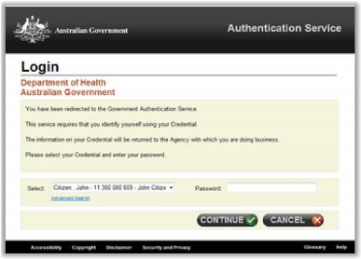 | STEP 1 – Select the AUSkey login.  STEP 2 – Select your AUSkey from the drop down menu.  There may be more than one user registered to your business accessing the PLMS from the same computer as you. Some users may also have different profiles for different businesses. Please make sure you select the correct AUSkey profile from the list provided.  STEP 3 – Enter your AUSkey Password.  STEP 4 – Click Continue to go to the next page.  ***AUSkey is being decommissioned end of March 2020. Please use the myGovID login option below from April onwards.

1.3 myGovID Login
If you are using myGovID opposed to AUSkey, click the myGovID login. You will need to use your myGovID credentials to login.
___________________________________________________________________________________________________________________
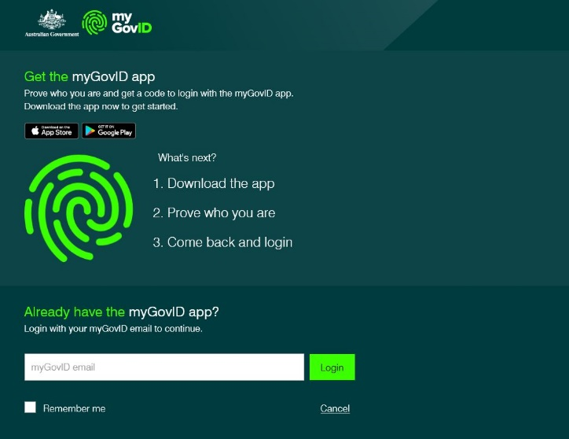

STEP 1 – Select the myGovID login.

STEP 2 – On the next screen, login using your myGovID email. If you haven’t logged in before, follow the prompts on the screen to get the myGovID app. Note: If you are acting on behalf of an organisation, you must make sure your RAM has already been set up before proceeding to the next step.

STEP 3 – Click login to go to the next page.

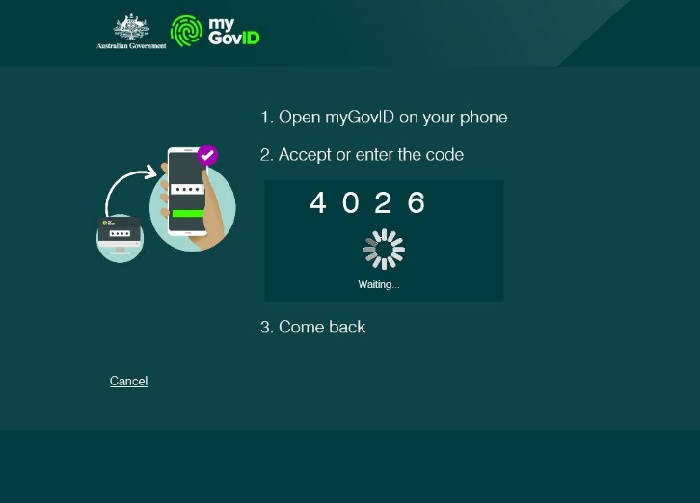
STEP 4 – Open the myGovID app on your phone and enter the four-digit code displayed on screen.

STEP 5 – The screen should refresh and take you back to PLMS.

1.4 Confirm Details
Read through your details to ensure they are correct.

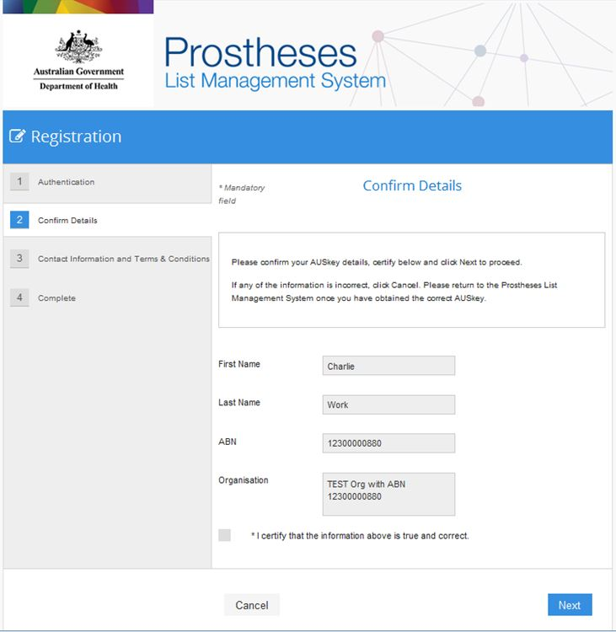 | STEP 1 – Check your AUSKey or myGovID details are correct.  If your AUSKey details are incorrect, please go to the Australian Business Register website, or contact 1300 AUSKEY (1300 287 539).  STEP 2 – Tick the box under your details to certify that the information above is true and correct.  STEP 3 – Click Next to save information and go to the next page.

1.5 Contact Information & Terms and Conditions
You will need to provide contact information, and accept the Terms and Conditions to gain access to the PLMS.

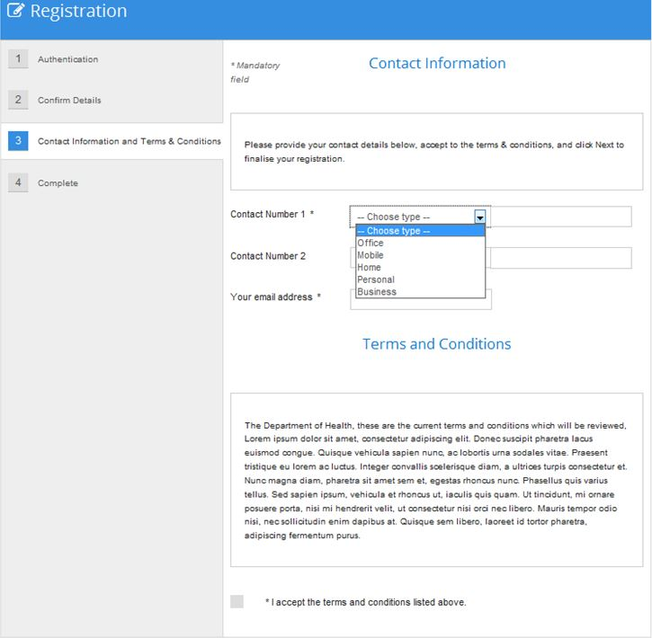 | STEP 1 – Select a Contact Number type from the drop down menu, and enter your number into the space provided.  You can also add a second contact number.  STEP 2 – Enter your email address.  STEP 3 – Read the Terms and Conditions and tick the box underneath if you accept.  STEP 4 – Click Next to complete your registration.

1.6 Complete
If you are presented with this screen, then you have successfully registered for the Prostheses List Management System.
Before you can view or edit applications, the User Administrator for your organisation must assign you a User Role(s). If you do not know who the User Administrator for your organisation is, contact the Department of Health at prostheses@health.gov.au
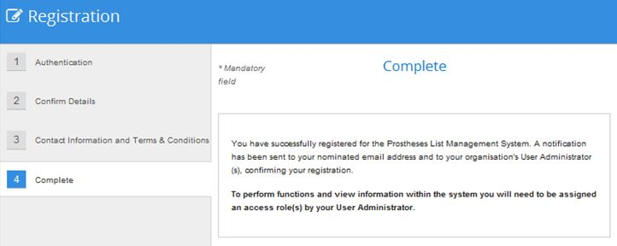 | STEP 1 – Click Finish to go to the PLMS Home.  Before you can view or edit applications, the User Administrator for your organisation must assign you a User Role(s).

1.7 PLMS Home
Once you have registered for the PLMS, you will be redirected to the PLMS Home. After the User Administrator for your organisation allocates you a User Role(s) in the system, you will be able to access a number of functions from the PLMS Home.
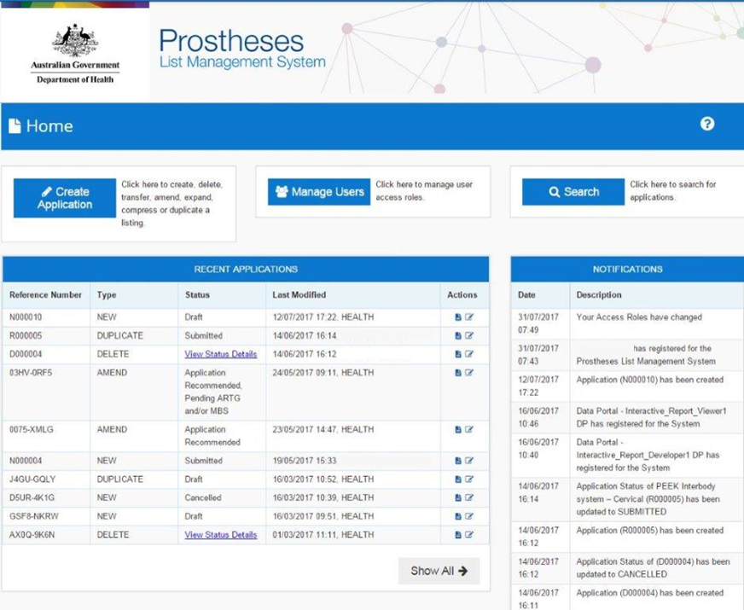 | Click Create Application to create, expand, compress, duplicate, transfer, amend or delete a listing from the Prostheses List.  Click Search to search applications.  Click Manage Users to manage User Roles (User Administrators only).  Click the icon to view the Application Summary of an application.  Click the icon to view and edit an application.  Click Show All to view a list of all of your applications.

2. Search
You can use the search function to search applications from your organisation.

You can search for applications by either:
- Application Number (Reference Number)
- Application Type (Create New, Amend, Expand, Compress, Duplicate, Transfer and Delete)

The steps to Search applications are:
Search
  - PLMS Home
  - Search Applications

2.1 PLMS Home
2. Search
2.1 2.2
You can access the search function from the PLMS Home.

STEP 1 – Click Search on the right hand side of the screen.

2.2 Search Applications
2. Search
2.1 2.2
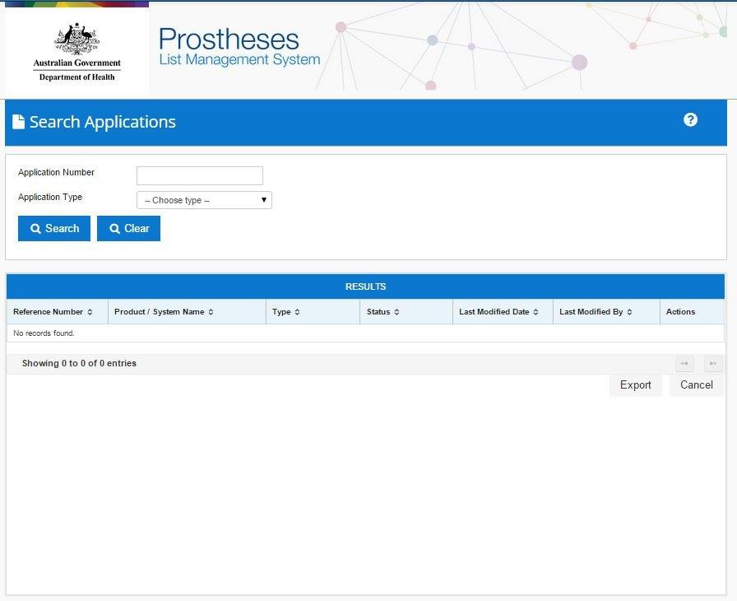 | STEP 1 – Search for an application by:  - Typing in the Application Number (Reference Number) in the space provided.  OR  - Selecting an Application Type from the drop down menu.  STEP 2 – Click Search. A list of search results will appear based on your search criteria.  GENERAL  Select theicon to view the Application Summary for an application.  Select the icon to view or edit an application.  Click Export to export your Results into an Excel spreadsheet.  Click Cancel to cancel your search.  You can filter your search results by clicking the headings under Results.  You have the option to filter search results by:  - Reference Number  - Product/ System Name  - Type  - Last Modified Date  - Last modified By

3. Manage User Roles
Only the User Administrator for an organisation has the authority to manage User Roles.

The User Role(s) determines what a user can see and do in the PLMS.
There are four types of User Roles in the PLMS:
- User Administrator
- Reader
- Author
- Approver

Once a user has registered for the system, the User Administrator must assign them a User Role(s). Users will not be able to view or edit applications unless they are assigned a User Role(s).

The steps to Manage User Roles are:
Manage User Roles
  - PLMS Home
  - List of Users
  - Prostheses Manage User Details Page

3. Manage User Roles
There are four types of User Roles in the PLMS:
- User Administrator
- Reader
- Author
- Approver

Overview of User Roles
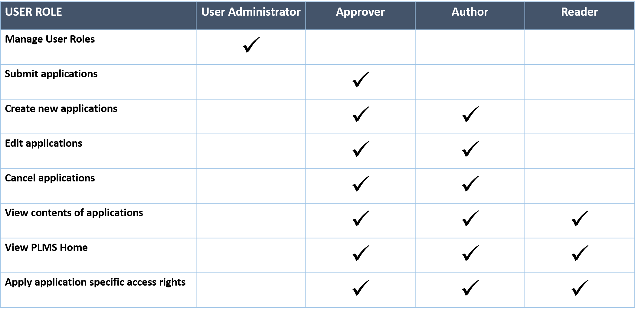

Note: A user can have more than one User Role assigned to their profile, e.g. a user can be both a User Administrator and a Reader.

For more information on User Roles, view the Quick Reference Guide: PLMS User Roles.

3.1 PLMS Home
3. Manage User Roles
3.1 3.2 3.3
User Administrators can access the Manage Users function from the PLMS Home.
Only the User Administrator for an organisation has the authority to manage User Roles. If you do not have a User Administrator role, this function will be unavailable to you.

STEP1 – Click Manage Users on the top middle of the screen.
Only User Administrators for an organisation will be able to access the Manage Users function.

3.2 List of Users
3. Manage User Roles
3.1 3.2 3.3
A screen showing a List of Users for your organisation will be shown.

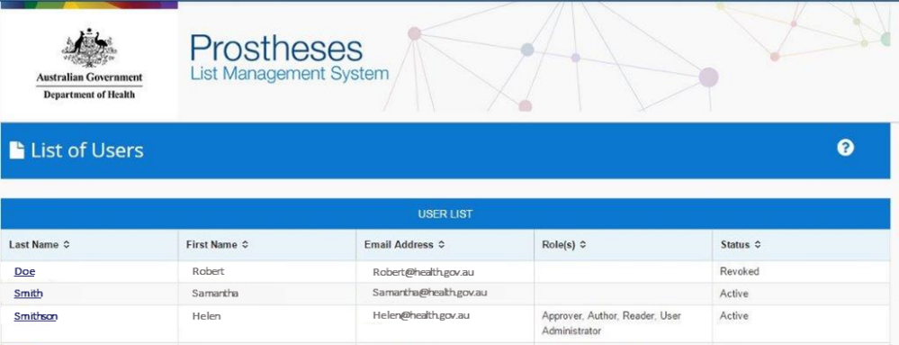 | STEP 1 – Click the Last Name on the user profile you would like to view.  You can filter users by clicking the headings under User List.  You have the option to filter by:  - Last Name  - First Name  - Email Address  - Role(s)  - Status

3.3 Prostheses Manage User Details Page
3. Manage User Roles
3.1 3.2 3.3
A User Administrator can manage User Roles and User Status information from this page.

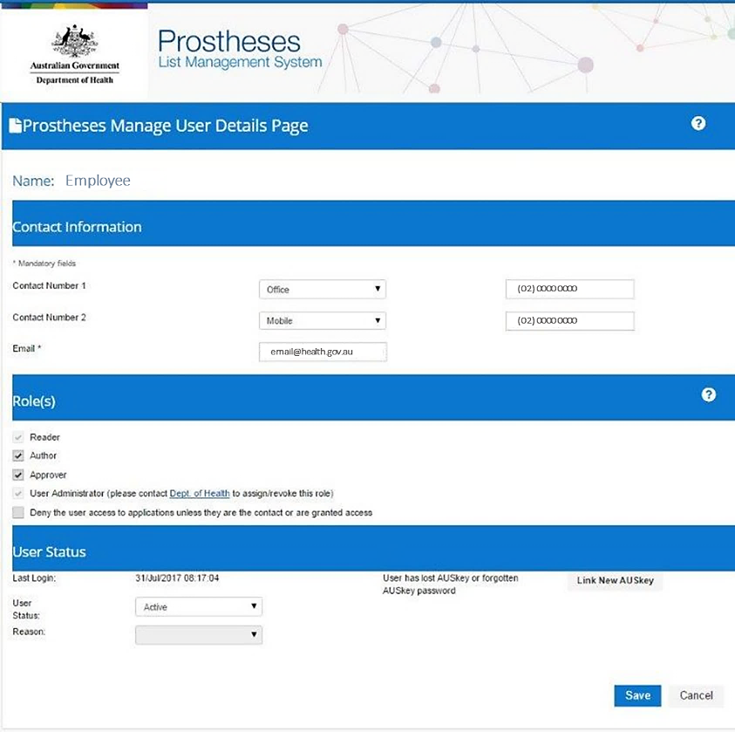 | Contact Information  Contact information is prefilled by the user.  The User Administrator will not be able to change Contact Information.  Role(s)  Tick the boxes relating to the User Role(s) or access permissions you want to assign to the user.  Click Save to save any changes on the page.  You can assign more than one User Role to a user.  The Department of Health grants the User Administrator role to the first registered user in an organisation. User Administrators cannot assign additional User Administrator roles in the system.  If your organisation would like to change the User Administrator role to another person or assign the role to additional users, contact the Department of Health at prostheses@health.gov.au  User Status  Use the User Status drop down menu to manage user access to the PLMS portal (e.g. Active, Revoked).  If you have revoked user access to the PLMS, please choose a Reason in the drop down menu.  Click Save to save any changes on the page.

